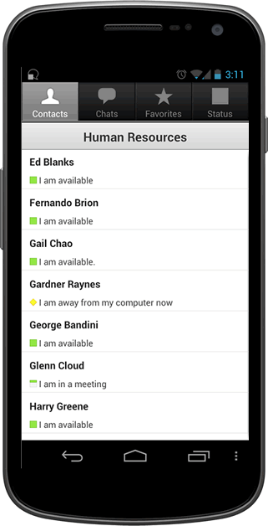

First Name

Last Name

Street Address

City

State

Zip

Do you own a vehicle?

Yes

No

Phone Number

My Profile



Log in

User Name

Password

**Carpooling for the Green Initiative**



Address: 145 Marcus way

Phone: 276-999-9999

Email: JohnDoe@yahoo.com

Vehicle Type: Car

Passengers: 4

John Doe



My Carpools

To Work Group:

Join Carpool

To Home Group:

Join Carpool

Create Carpool



Notifications



Max Passengers

Vehicle Type

Save Changes

Delete Account

Do you own a vehicle?

Yes

No

Truck

Van

SUV

Car

Other

My Profile

Days Willing to Drive

Mon Tue Wed Thu Fri Sat Sun



Calculate Fee

Vehicle’s mpg

Distance of trip (miles)

Number of Passenger

(Do not include driver)

Cost for gas (per gal) $

Total

$0.00

Carpool Calculator

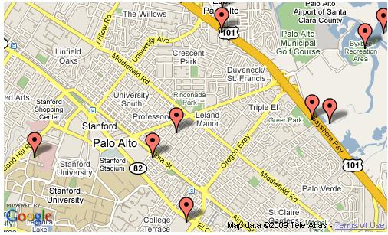

Cool Pool 1

Cool Pool 2

Find Carpool



Cool Pool 1

Members

John Doe- Leader

Sarah Coleman

Sam Davis

John Doe- Leader

Sarah Coleman

Sam Davis

To Work

To Home

Meeting Place: 145 Marcus way

To work: 7:15 am

To home: 5:30 pm

Days: M W F

To Work available: 2

To Home available: 1

Request to Join Group

Request to Join Group

* If user is not in that group

Cancel Join Request

* If user is pending in joining the group



My Carpools

To Work Group:

Cool Pool 1

To Home Group:

Join Carpool

Create Carpool



Notifications

Stanley Johnson wants to join Cool Pool 1

Jonny William wants to Cool Pool 1

Accept

Deny

Accept

Deny



Cool Pool 1

Members

John Doe- Leader

Sarah Coleman

Sam Davis

John Doe- Leader

Sarah Coleman

Sam Davis

To Work

To Home

Meeting Place: 145 Marcus way

To work: 7:15 am

To home: 5:30 pm

Days: M W F

To Work available: 2

To Home available: 1

Request to Join Group



Meeting Place:

Time to Home:

Time to Work:

Create

Create Carpool

Carpool Name

ome



Cool Pool 1

Members

Message Carpool

John Doe- Leader

Sarah Coleman

Sam Davis

John Doe- Leader

Sarah Coleman

Sam Davis

To Work

To Home

Meeting Place: 145 Marcus way

To work: 7:15 am

To home: 5:30 pm

Days: M W F

To Work available: 2

To Home available: 1

Get Route

Schedule

Leave Group

Delete Group

Send “Leaving Now” Text

Send Custom Text



Cool Pool 1

Members

Message Carpool

John Doe- Leader

Sarah Coleman

Sam Davis

John Doe- Leader

Sarah Coleman

Sam Davis

To Work

To Home

Meeting Place: 145 Marcus way

To work: 7:15 am

To home: 5:30 pm

Days: M W F

To Work available: 2

To Home available: 1

Get Route

Schedule

Leave Group

Delete Group



Monday

Tuesday

Wednesday

Thursday

Friday

Saturday

Sunday

Schedule

John Doe

John Doe

John Doe



Address: 145 Marcus Way

Phone: 276-999-9999

Email: johnDoe@company.com

Vehicle Type: Car

Passengers: 4

John Doe